**DAILY ONLINE ACTIVITIES SUMMARY**

|  |  |  |  |  |  |  |  |  |
| --- | --- | --- | --- | --- | --- | --- | --- | --- |
| **Date:** | **13/06/2020** | | | | | **Name:** | **Soundarya R** | |
| **Sem & Sec** | **6th & B** | | | | | **USN:** | **4al17cs096** | |
| **Online Test Summary** | | | | | | | | |
| **Subject** | | **PAP** | | | | | | |
| **Max. Marks** | | **30** | | **Score** | | | **9** | |
| **Certification Course Summary** | | | | | | | | |
| **Course** | **Mastering Big Data Analytics** | | | | | | | |
| **Certificate Provider** | | | **Great Learning Academy** | | **Duration** | | | **21 hrs** |
| **Coding Challenges** | | | | | | | | |
| **Problem Statement:2 programs** | | | | | | | | |
| **Status:solved** | | | | | | | | |
| **Uploaded the report in Github** | | | | | **yes** | | | |
| **If yes Repository name** | | | | | **http://github.com/ashu102/Daily-Activties** | | | |
| **Uploaded the report in slack** | | | | | **yes** | | | |

Online Test Details:

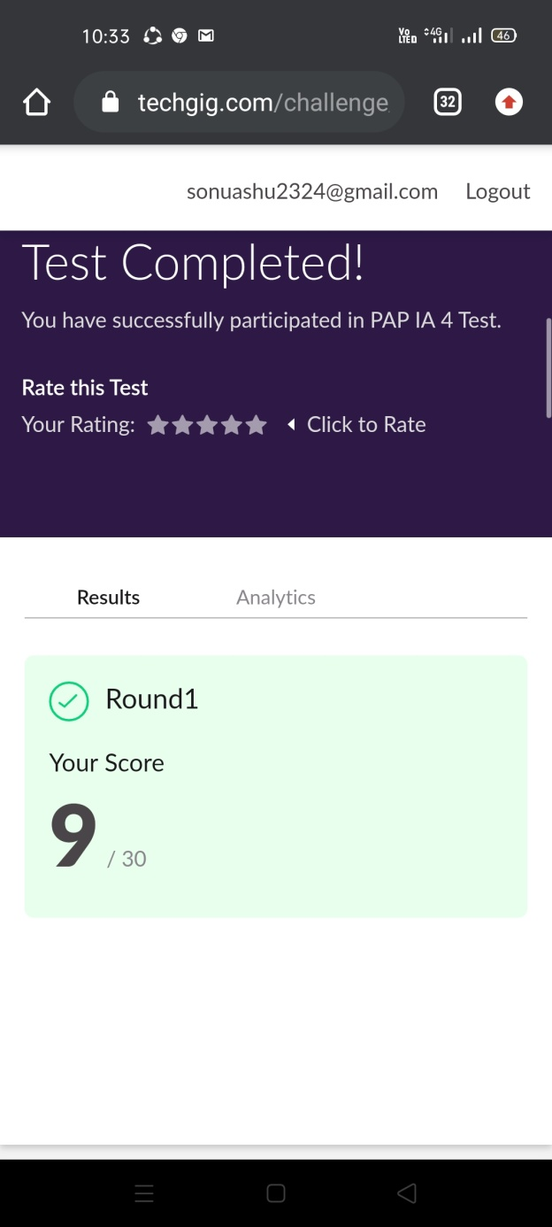

Certification Course Details:

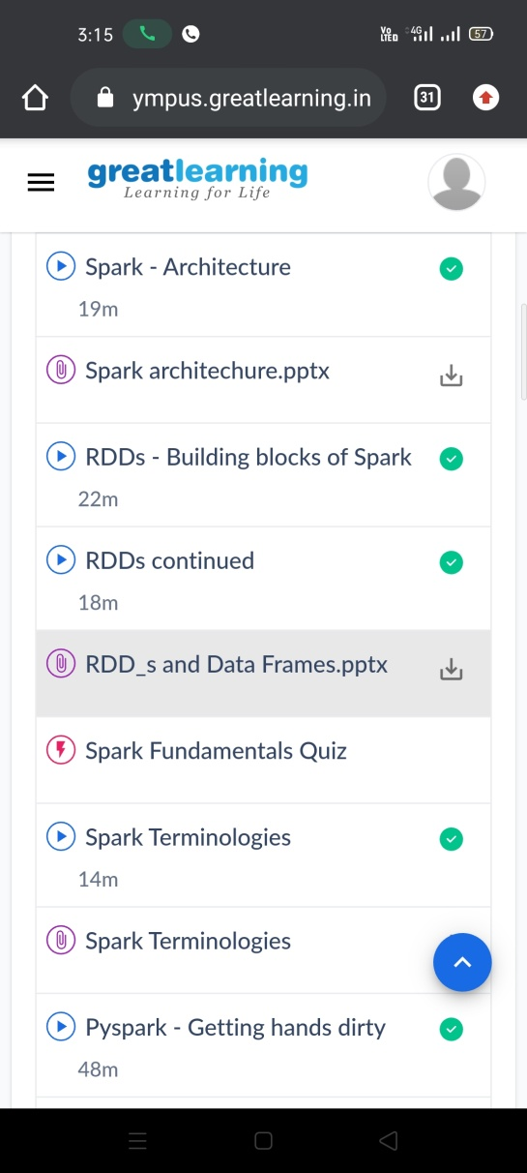

Coding Challenges Details:

1. Write a Java Program to determine whether a given matrix is a sparse matrix

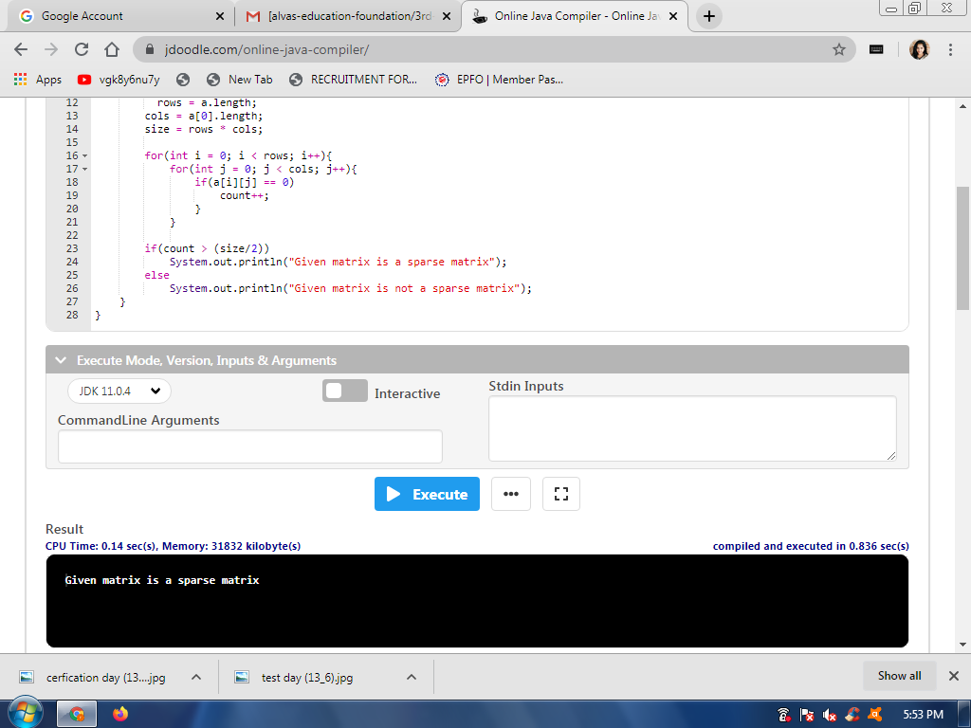

2. How to find the first non repeated character of a given String

